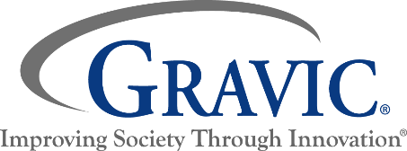
Customer Satisfaction Survey

This survey has been designed to find out how satisfied you were with our service today. The results of this survey will be used to improve these services to our customers. Please be assured that your response will be held completely confidential.

Read the questions below and select the response that best describes your experience

Career Center Workshop Survey

1. How many Workshops have you attended at the Career Center?
O First Time O 2 to 3
O 4 to 5 O 6 or more

Please answer the following questions with:
1 = Strongly Agree, 2 = Agree, 3 = No Opinion, 4 = Disagree, and 5 = Strongly Disagree

2. I found the Workshop information helpful. |  |  |  |  | 
3. The material and/or equipment was useful and in good working order. |  |  |  |  | 
4. The Workshop met my expectations and goals. |  |  |  |  | 
5. Overall, the Workshop staff was friendly, helpful, and knowledgeable. |  |  |  |  | 

6. Would you recommend this Workshop to a friend?

O Yes O No

How can we serve you better?

Do you want someone to contact you? O Yes O No

If YES please put your name, address, and phone number on the bottom of this survey.

Name: ____________________________ Address: ______________________________ Phone: ____________________

